**How To Work The Camera**

**How to turn on the camera:**

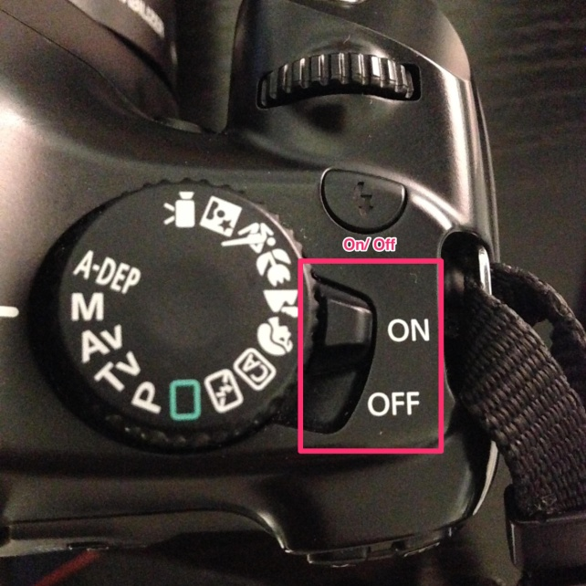

* **Flip the switch then**
* **A mechanical noise should be heard**
* **It is on**

**How to put in SD card:**

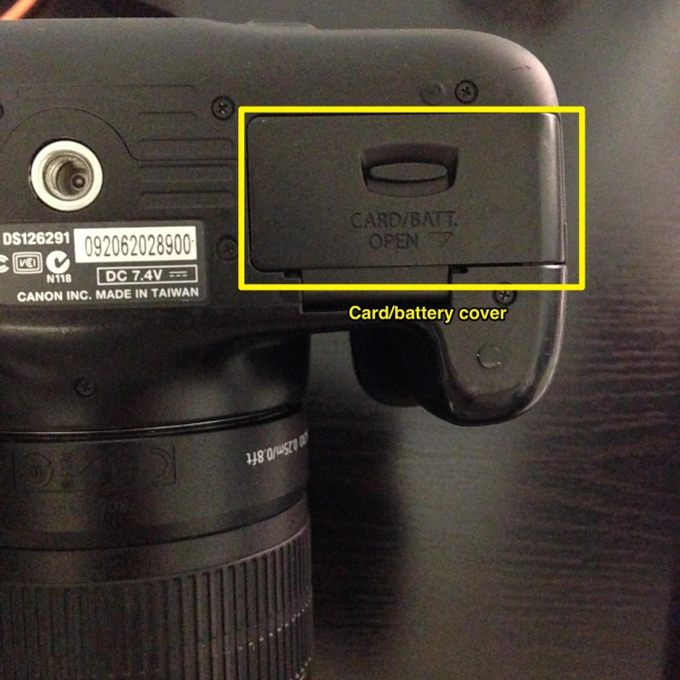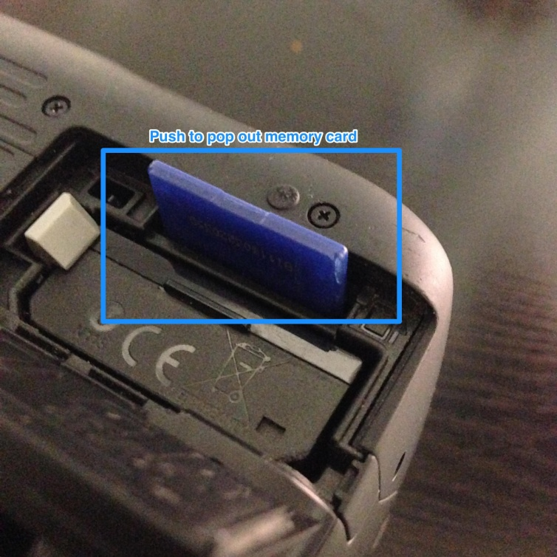

* **On the bottom of camera there will be a card/battery cover**
* **Open cover**
* **Push on the SD memory card to eject**

**How to take on/off the lense:**

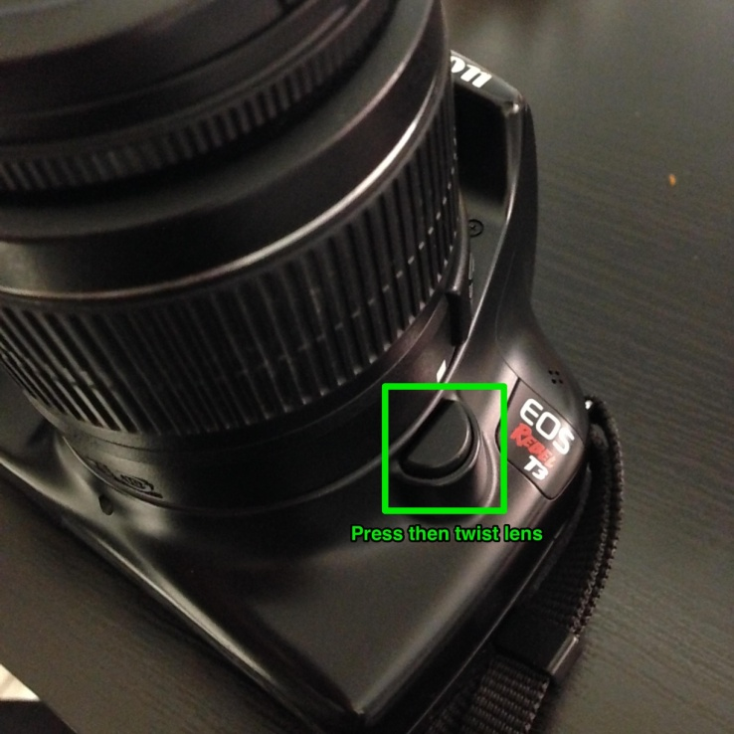

* To take off the lense, press the moon shaped button on the right side of the lense
* Twist the lense counterclockwise
* Pull off

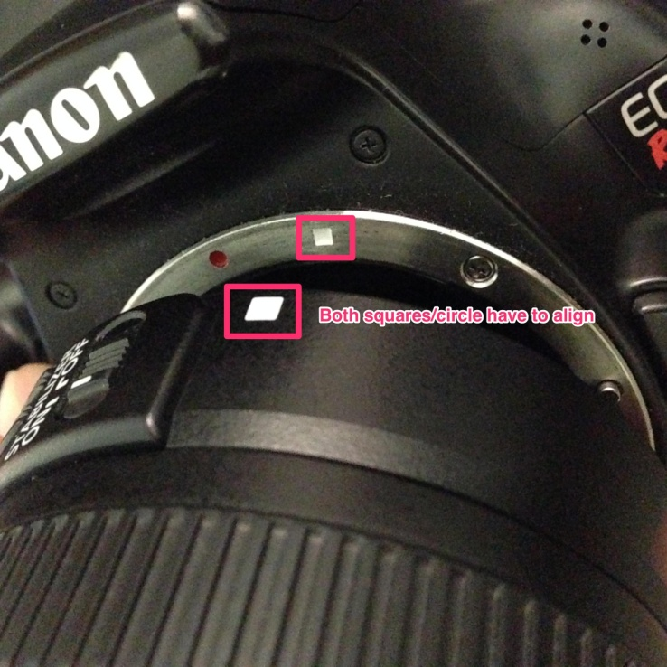

* To put on the lense line up the shape on the lense and camera body
* Twist clockwise

**Changing the modes:**

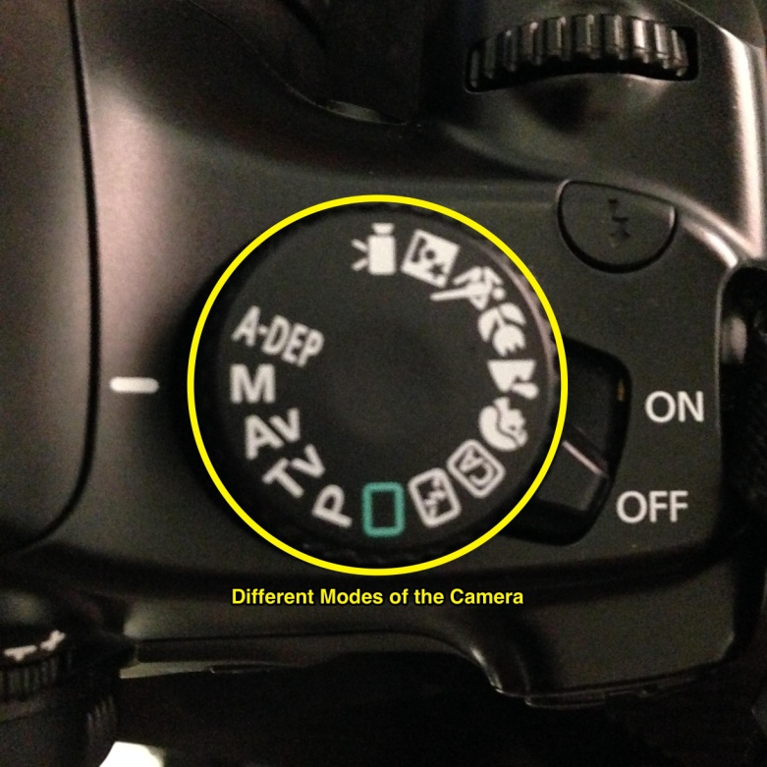

* + **M -** Manual Mode. Have control over the settings of the camera
  + **P -** Program Mode. Less customizability in settings
* Ideally for the hardware right now the preferred mode is on the Manual mode (**M)**

**Changing camera settings:**

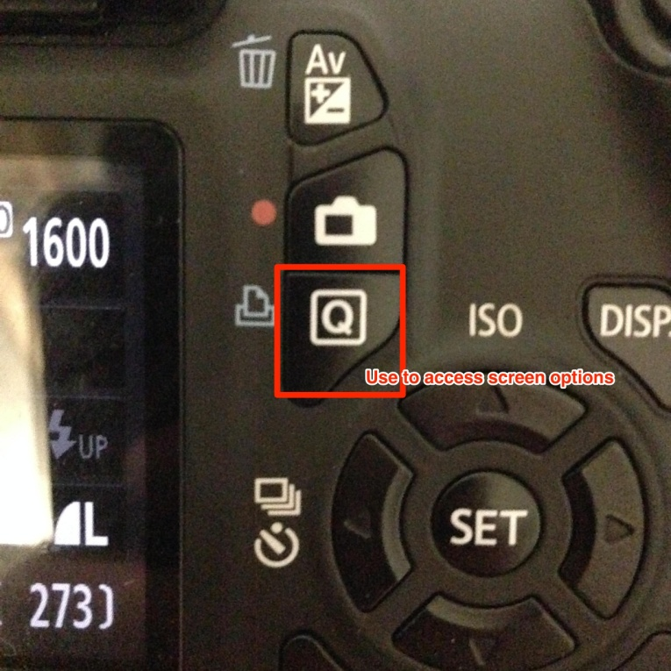

* When the camera is on lightly press down on the shutter button (the “take picture button”)
* And then when you see the LCD display light up press the **Q** button and use the arrow keys to navigate around the screen

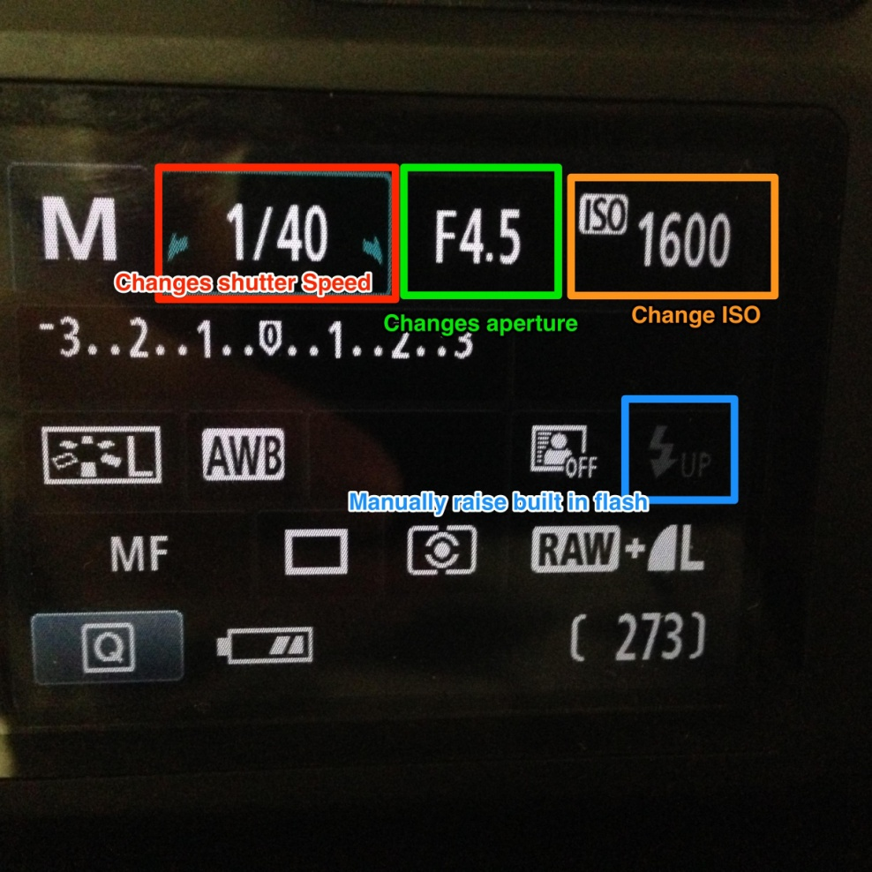

* While in this screen from left to right the settings change the:
  + Shutter speed
  + Aperture/ Fstop
  + ISO
* The **BoltUP** button is used to raise and control the built in flash.

**Working with the flash:**

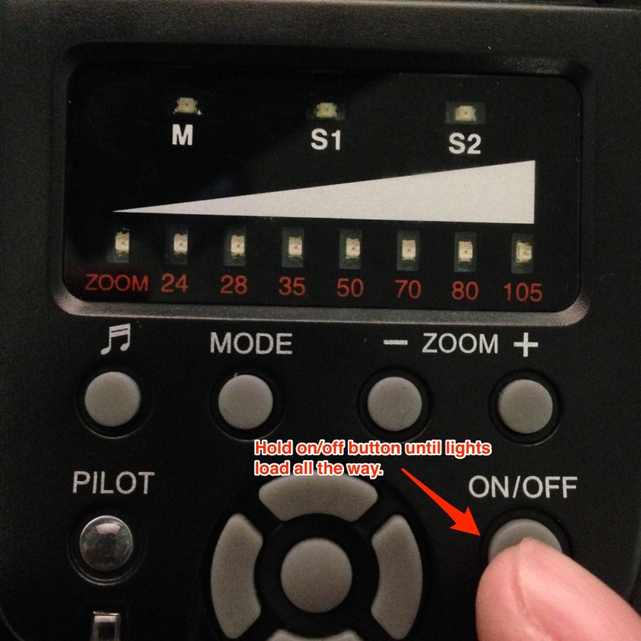

* To turn on the **YN560 Flash,** hold the power button until all the zoom lights load up.

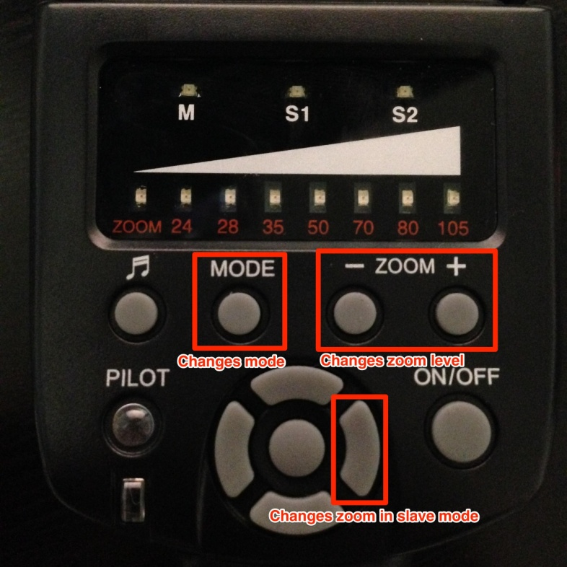

* The  **Mode** button allows you to cycle through the three options:
  + **M -**  Manual Mode, the flash is directly attached to the camera and or through the cable.
  + **S1 -** Slave one mode which allows for the flash to be triggered wirelessly
  + **S2 -** Same as S1
* The **ZOOM** button allows you to change the zoom of the flash. i.e How far the flash’s light is going to travel to reach the object.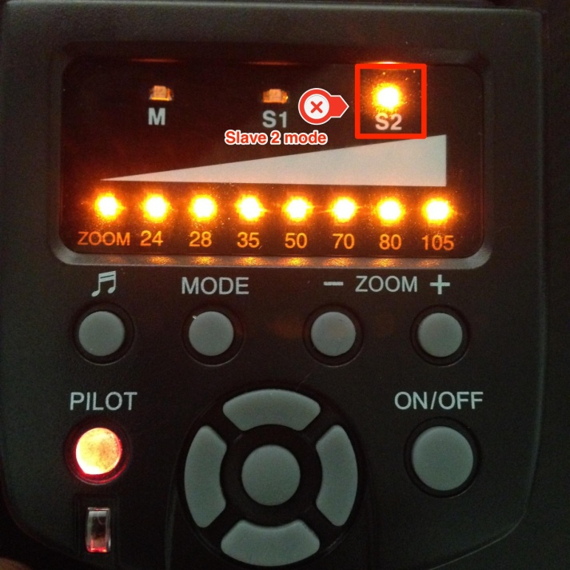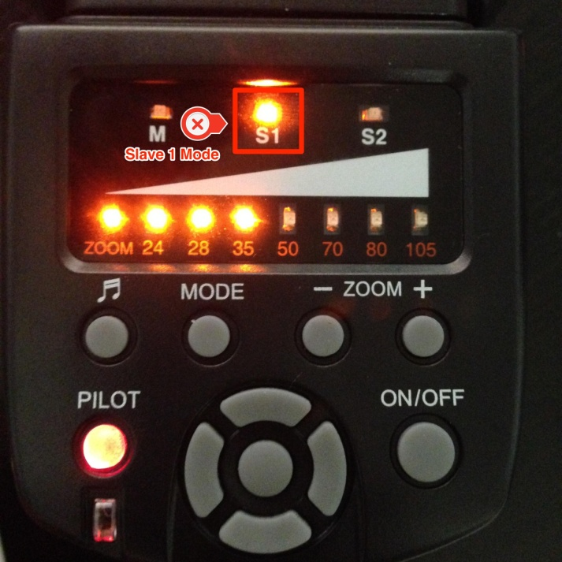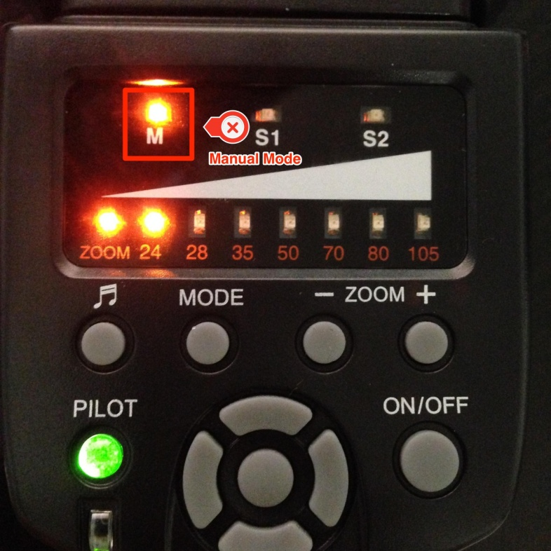

**Attaching the Flash:**

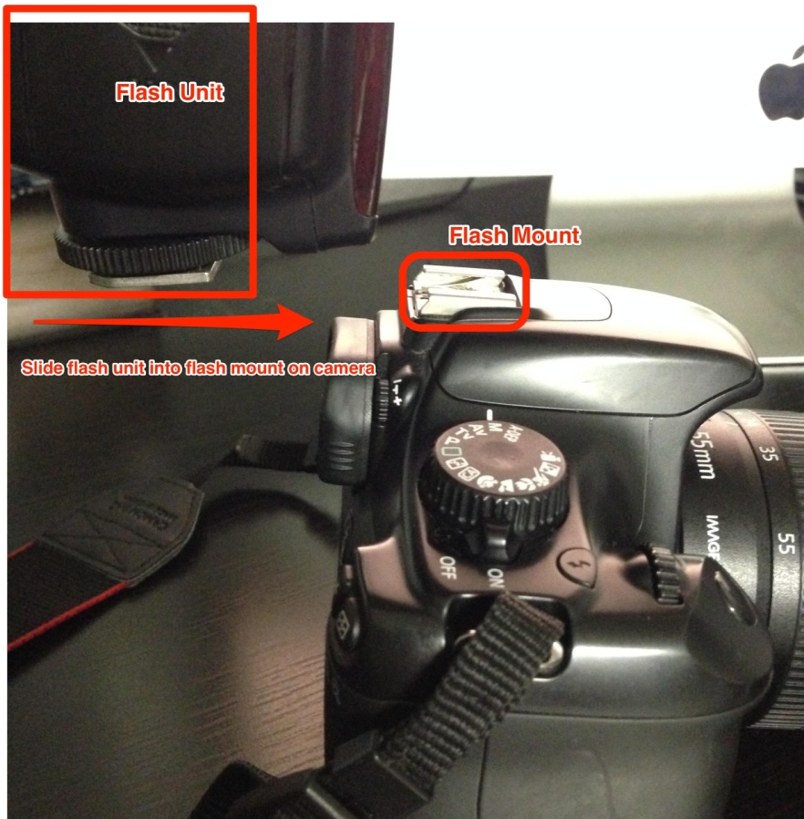

* To attach the flash just slide the camera into the top flash mount of the camera.
* The flash can be mounted either directly to the camera or through a cable.

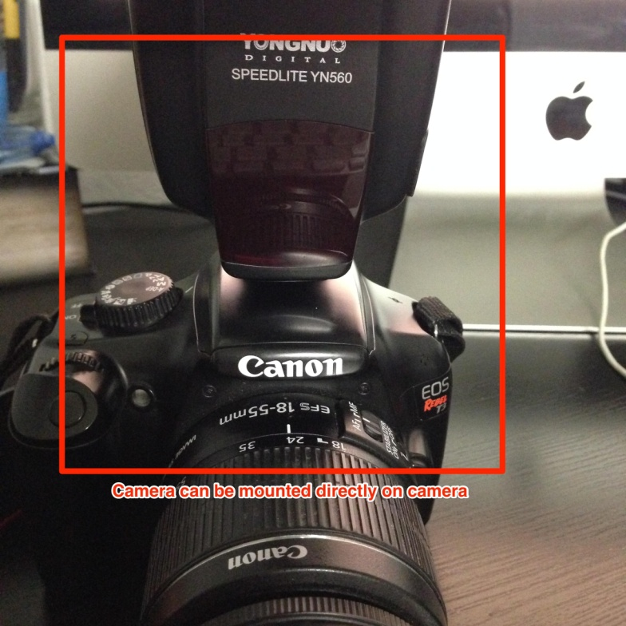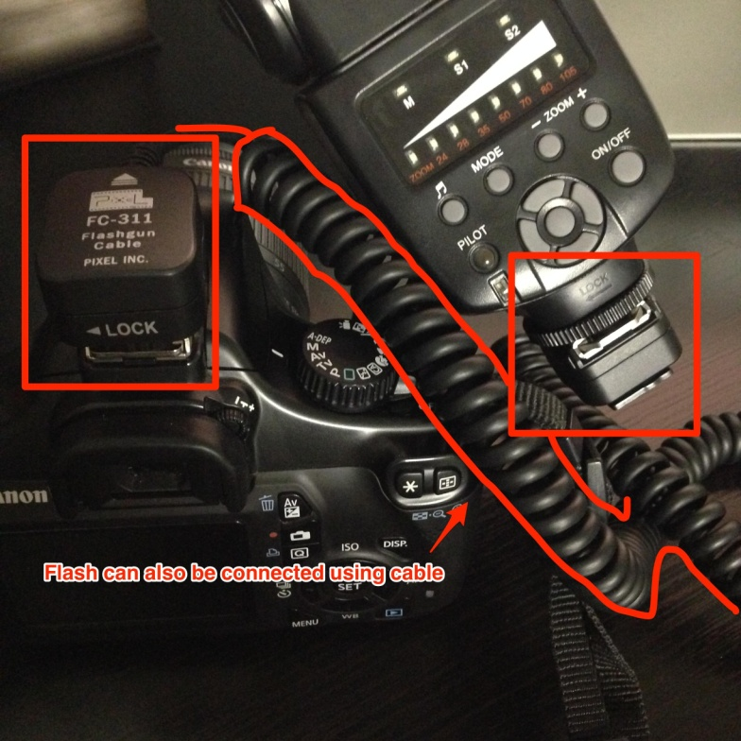

**Optimal Camera Settings for Red Eye Production:**

* The camera’s settings should be:

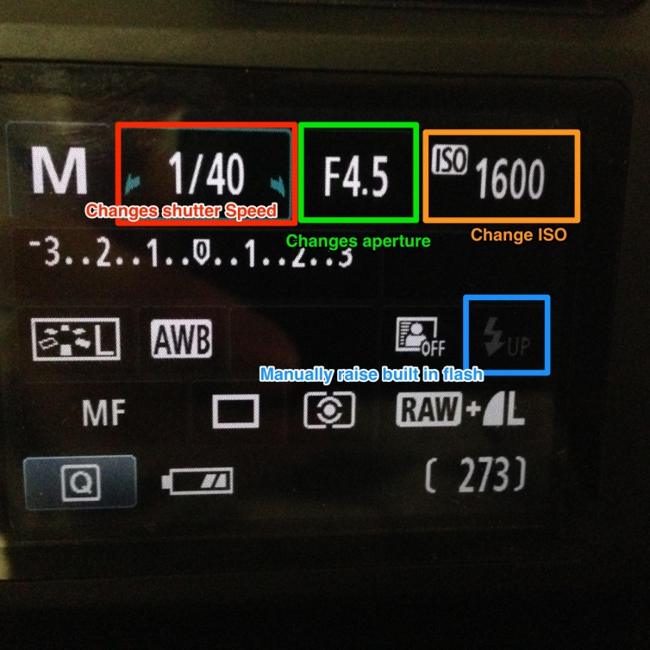

|  |  |  |
| --- | --- | --- |
| Shutter Speed | Aperture | ISO |
| **1/40** | **F5.6** | **1600** |

* Flash’s zoom should be set at **35.**

**For our testing, the red eye reproduction was best suited when the subjects were in a completely dark environment before taking the photo.**

* **Issue with above however, is that the environment had to be completely dark**
* **Also hard to take photo in complete darkness**

**TEST PHOTOS**

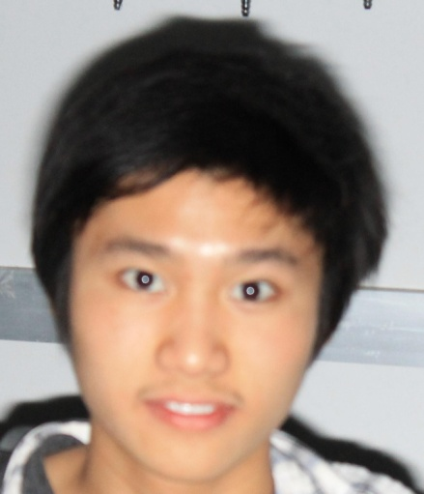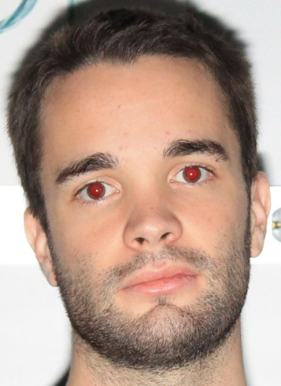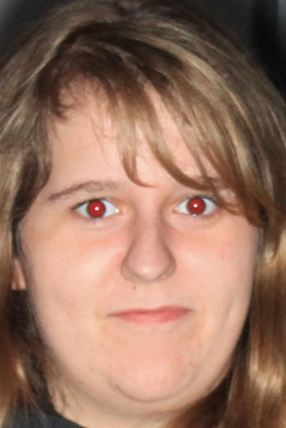

**Bracket Prototypes:**

* **Bracket Mount 1:**

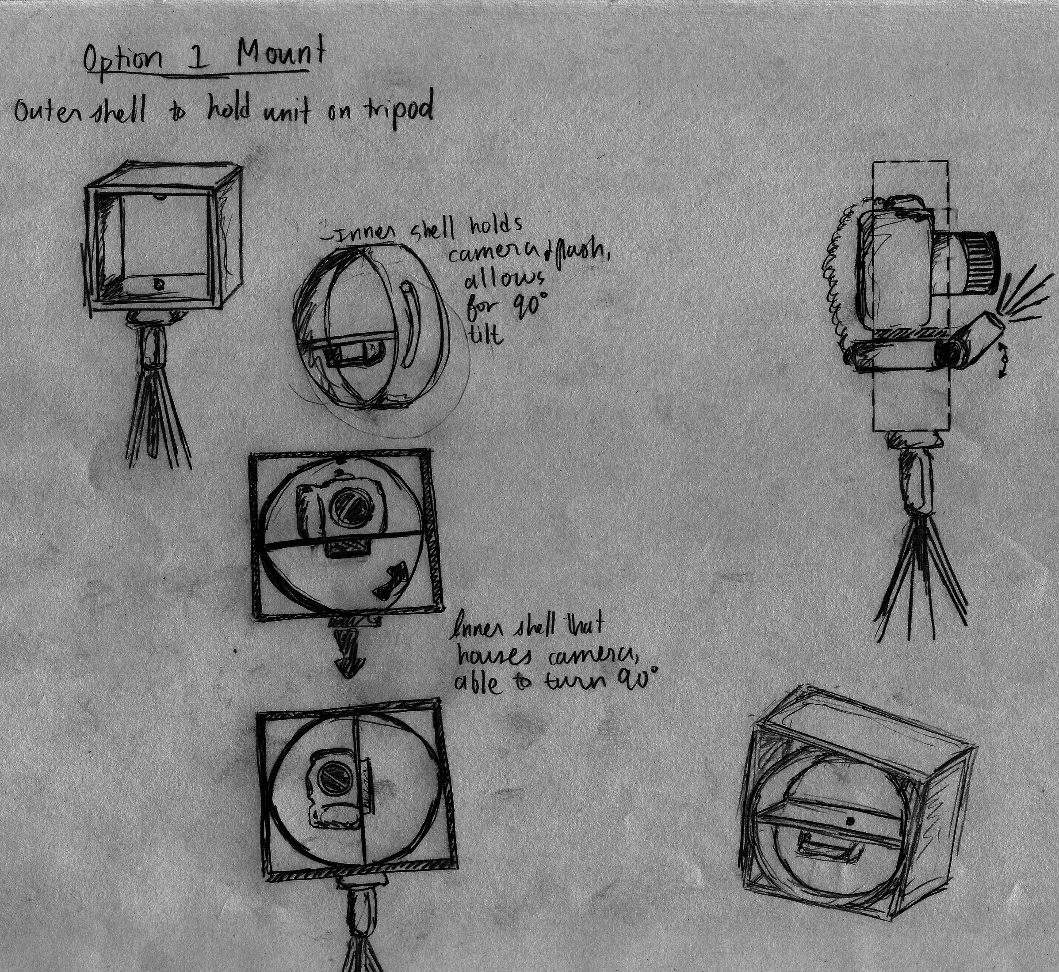

* This bracket design uses two shells and inner one and an outer one
* The inner shell is used to rotate the camera around its axis
* The outer shell is used to house everything onto the tripod.
  + Pros:
    - This design is very efficient and compact
    - Easy to maneuver around
    - Very Modular
  + Cons:
    - The fabrication can be difficult
    - The rotation mechanism may be a little difficult to make
* **Bracket mount 2:**

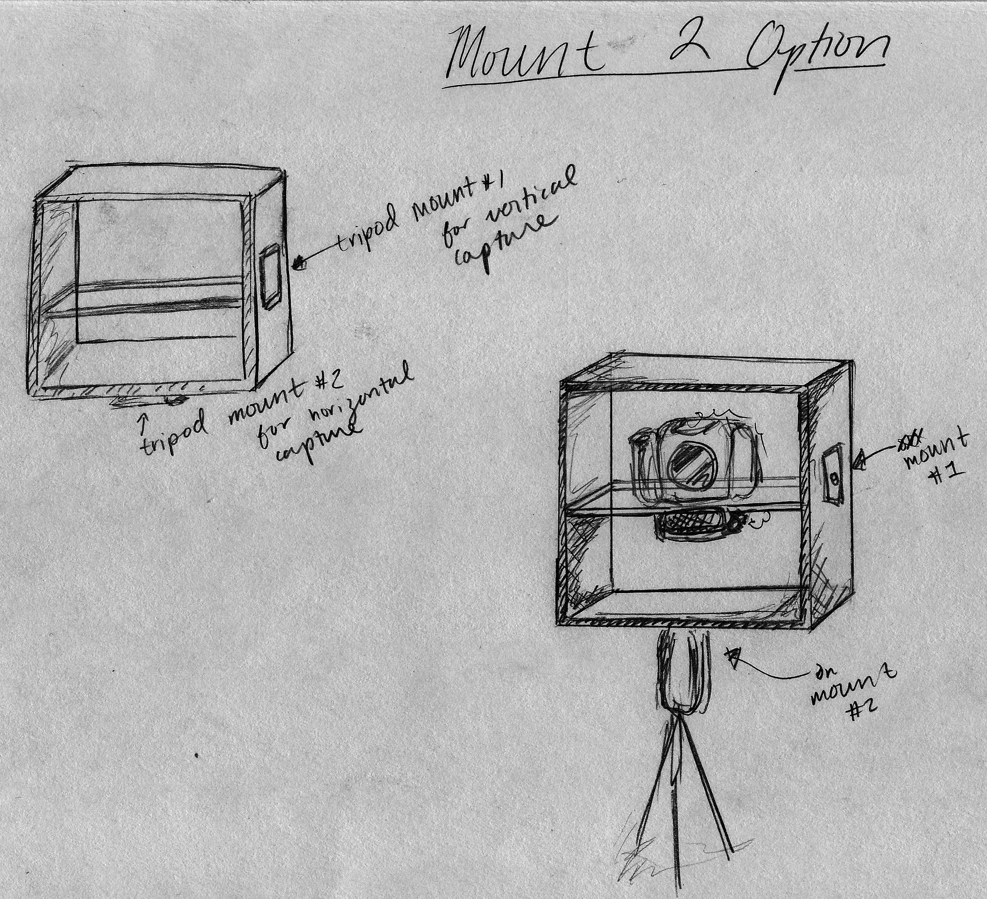

* This design is similar to Design 1 however it only has the outer shell
* Outer shell has two mounting points
* These mounting points is use to re-mount the camera horizontally or vertically
  + Pros:
    - Extremely cost effective
    - Easy to make
    - Simple and maneuverable
  + Cons:
    - Very cumbersome to change orientation
    - Requires a lot of fiddling
* **Bracket Mount 3:**

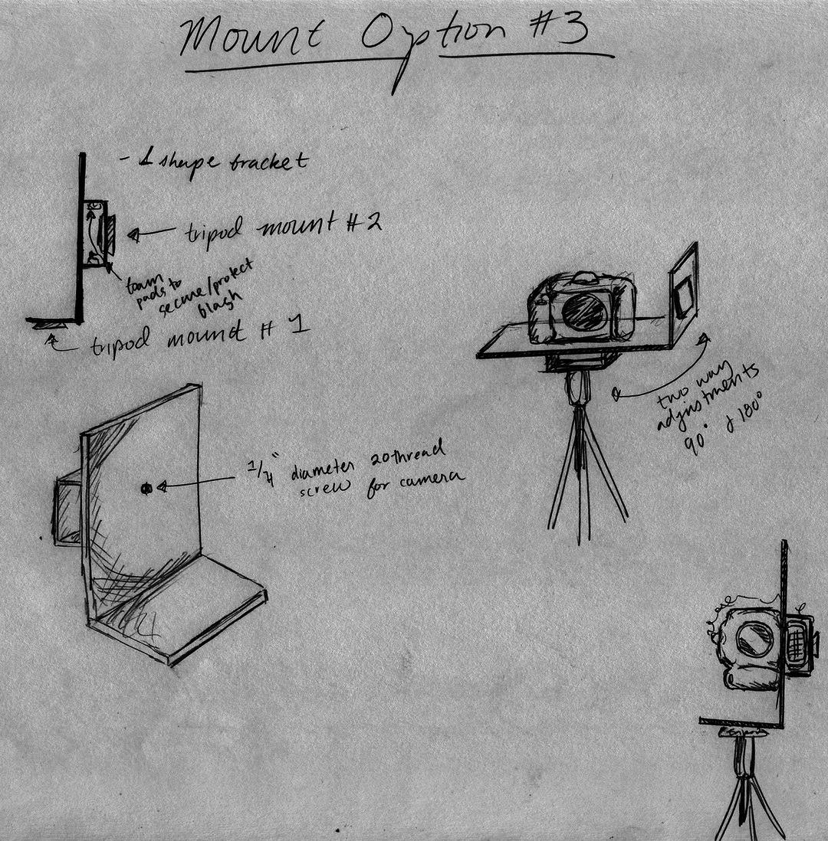

* This is an L-shape bracket
* Houses both the camera and flash
  + Pros:
    - Extremely light weight
    - Extremely easy to make
    - Super cost effective
    - Very customizable
  + Cons:
    - The way the bracket has to be re-mounted for vertical and horizontal pictures is cumbersome

**Current Hardware That We Have:**

* Canon EOS Rebel T3 Camera Body
* Pixel FC-311 Flashgun Cable
* 8GB Eye-Fi memory card
* Yongnuo YN560 Speedlight Flash
* Canon 270EX II Speedlite Flash
* Canon 55-250 mm lense
* Canon 18-55mm lense